VP meeting
- LEE DOS
- Associates don’t know where things should be going.
  - Been training/mentoring new DOD associates and there’s a lot of new/different teams that it is a learning curve.
  - Example
    - JLV seen go to Leidos T3, onsite, accounts team, FSI
    - LEIDOS/new TEAMS
      - MHS_Genesis_NonProd_Accounts_DoD
      - MHS_Genesis_Tier_3_Accounts_DOD
      - MHS_Genesis_Tier_3_DoD
      - LPDH_Dental_SustainmentSupport_DoD
      - iAccess_GovWks_DoD
  - New Acronyms that get referenced a lot.
  - TENT CARDS?
    - MHSG, MHSSHD, DMDC, JSAAB, DMISS
- Things are being juggled between accounts teams Cerner and onsite (causing missed SLA)
  - Example
- Tickets are sitting too long that could be resolved but aren’t being kept up with enough.
  - Example
    - The tickets that people don’t know what to do with sit longer
- Sometimes it takes a while for a ticket to get to cerner from onsite or Leidos
- Transfers
- We are having to be a jack of all trades vs AMS we have silos
- SLA – Tickets will go to a random team bounce around then come back and SLA will be missed
- Old devices 449123542/449127113/449222696/449226857/448910359
- JLV
  - Tried FHIR > Mpages > FSI > T3 accounts
- video visit or Video connect 446419167 446410003
  - Sometimes scheduling
  - Can be onsite.
    - Steve Skojec 447642803
  - B side 449148407
  - Can be FSI
- ROES
  - CWx > FHIR > BSide

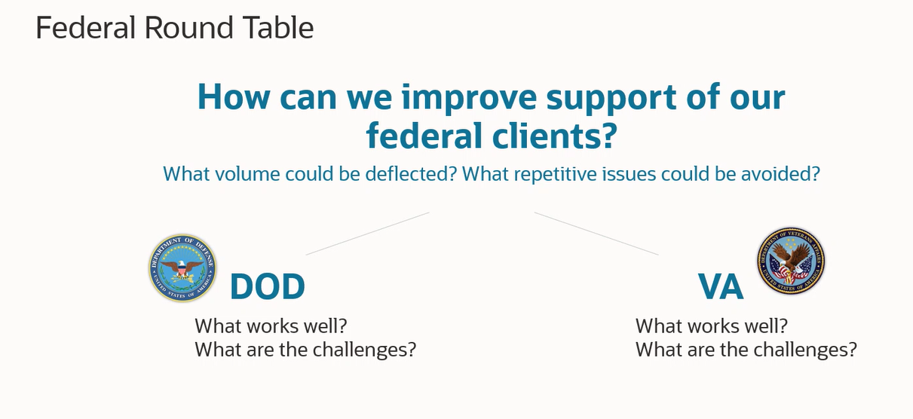
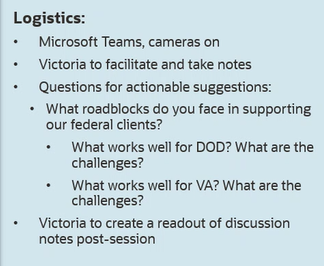

- Chhour, Danny
  - Full page screenshots provided on tickets. One per ticket

